**FDI (Federal Debris Inspector)**

**Adam Vandyke (101023594,** [**adam.s.vandyke@gmail.com**](mailto:adam.s.vandyke@gmail.com)**)**

**Jamie Allen (100973636, jamiea483@hotmail.com)**

**High Level Description:**

Flax is a single player game where the players objective is to fly through space gathering specific items to gain points, for each item collected the player will get a new order for a specific item. If the player collects an incorrect item there will be a deduction from the players score and they will receive a new item to collect

**Screen Layouts:**

**Game Screen**

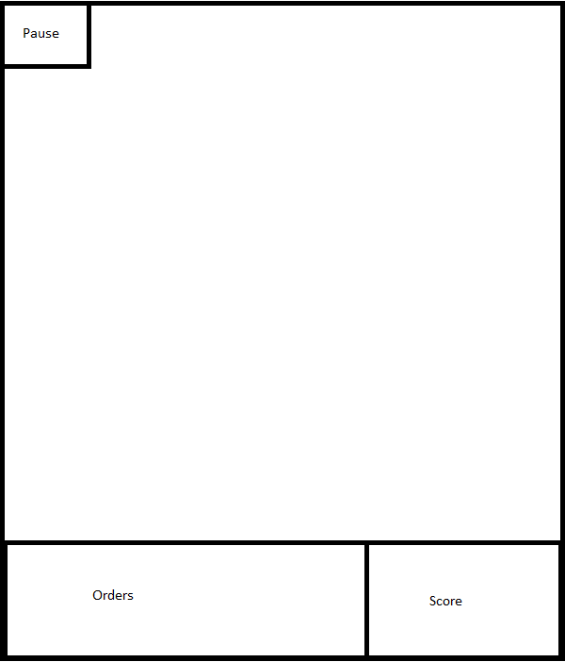

**Pause Screen**

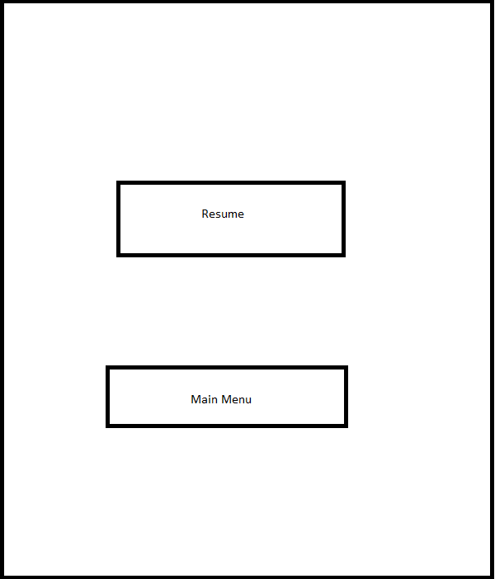

**Game Over Screen**

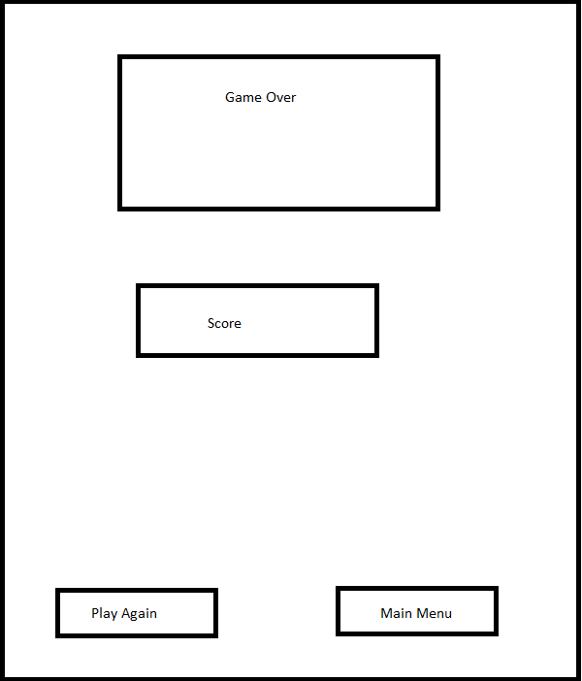

**Backstory:**

You are a Federal Debris Inspector your job is to go between stars and Inspect various space Debris and catalogue them in order for your superiors, unfortunately you’re an Alcoholic and complete mess and are way behind on your missions you awake one day with 10 mins from your submission time you better move fast to get your tasks done.

**Game Mechanics:**

-Items appear randomly on the screen.

-Fly into items to collect them.

-Gather specific items to gain points.

-Gathering items spawns new ones.

-If wrong items are gathered points are deducted.

-At the end of the time limit the game is over.